AARKI ANALYTICS CHALLENGE
Lead Quality Analysis & Optimization Recommendations

Prepared by
Satyam Mishra
Data Analyst | SQL • Excel • Power BI • Business Analytics
B.Tech in Electronics & Communication Engineering with AI & ML, NSUT

satyam.mishra.dec17@gmail.com | +91 8882687033
linkedin.com/in/satyam-mishra-dec17

May 2026 | Associate Analyst Application – Bengaluru

Executive Summary
This analysis examines a dataset of 3,021 leads generated through multiple advertising creatives, publisher placements, and acquisition channels for a debt reduction advertiser. The objective was to evaluate lead quality trends, identify the key drivers of downstream conversion quality, and recommend optimizations that could justify a higher Cost Per Lead (CPL).

Key Findings at a Glance
- Trend volatility, not decline: Weekly lead quality fluctuated but was not statistically significant at the 95% confidence level, indicating normal operational variance.
- Creative design matters: Widget design and form structure had a material impact on downstream lead quality outcomes.
- Validation signals are predictive: PhoneScore and AddressScore demonstrated a strong positive correlation with close rates.
- Significant untapped opportunity: Approximately 71% of leads remained in an 'Unknown' status, representing a major operational gap.
- Segment performance varies: Certain publisher placements and creative variants consistently outperformed others.

Highest-impact opportunity: Prioritising high-validation-score leads and reallocating traffic to stronger widget variants could materially improve lead quality and support a CPL increase.

1. Objective
This analysis was structured to answer three core business questions:
- Trend direction: Are lead quality trends improving or declining over time?
- Quality drivers: What factors most strongly influence lead quality?
- CPL justification: Can lead quality improve sufficiently to justify a 20% increase in advertiser CPL?

2. Data Cleaning & Preparation

Lead Quality Mapping
The original CallStatus field was standardised into three analytical categories to enable consistent cross-segment comparison:

Category | Included Statuses
Good | Closed, EP Sent, EP Received, EP Confirmed
Bad | Unable to Contact, Invalid Profile, Doesn't Qualify
Unknown | All remaining statuses

Approximately 71% of leads remained in the 'Unknown' category — representing a substantial opportunity to improve operational follow-up and qualification workflows.

Key Performance Indicators

Key Performance Indicator | Value
Total Dataset Leads | 3,021
Known / Evaluable Leads | 881
Good Lead % (Known) | 44.6%
Bad Lead % (Known) | 55.4%
Overall Closed Rate | 8.1%
Closed Rate (Known Leads) | 27.8%

3. Trend Analysis
Weekly lead quality was tracked using the Lead Created Date field. Good Lead Rates and Bad Lead Rates were calculated and assessed for directional movement over the analysis period.

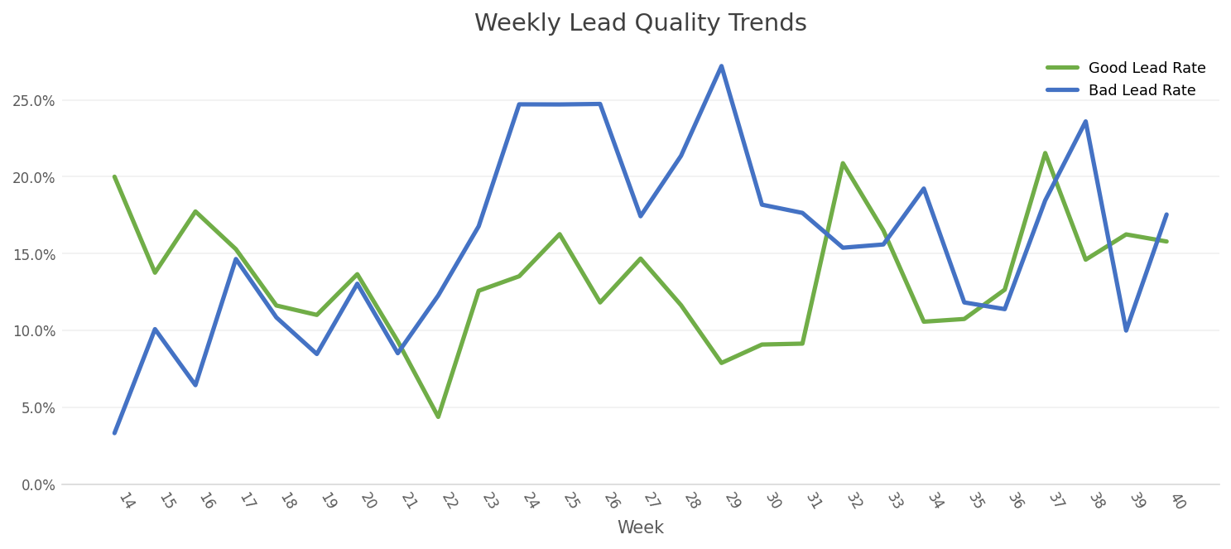

Key Findings
- Lead quality fluctuated substantially across weeks.
- Several periods experienced elevated Bad Lead Rates.
- No sustained improvement trend was observed over the analysis window.
- Traffic quality appeared operationally volatile rather than directionally deteriorating.

Conclusion: Lead quality did not exhibit a consistent upward or downward trend — variance appears to be driven by operational factors rather than systemic campaign degradation.

4. Statistical Validation
To determine whether observed fluctuations were meaningful, a Chi-Square test was applied comparing Early vs. Late lead periods. Unknown leads were excluded; a contingency table was built using Good vs. Bad leads.

Chi-Square Results

Metric | Result
Chi-Square Statistic | ~1.84
Degrees of Freedom | 1
Critical Threshold (95%) | 3.84
Significance Level | 95%
Conclusion | Not Statistically Significant

Because the Chi-Square statistic (1.84) remained below the 95% critical threshold (3.84), observed fluctuations were not statistically significant — consistent with normal operational variability.

5. Widget Performance Analysis
Creative-level analysis was conducted to determine whether widget design and form structure influenced downstream lead quality. Good Lead % was calculated using evaluable leads only.

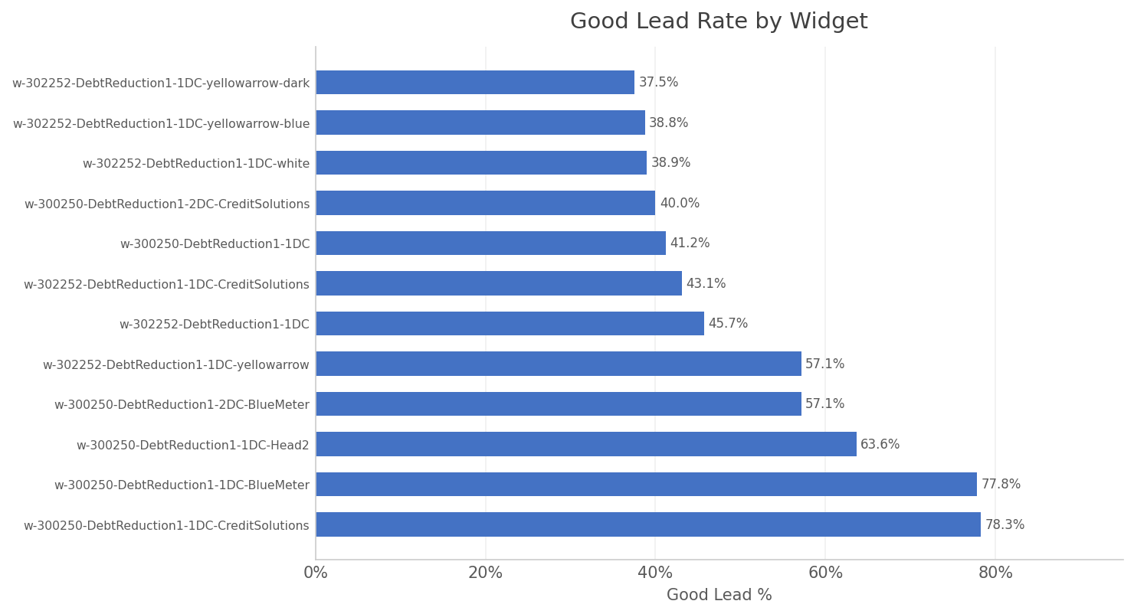

Key Findings
- Significant quality variation existed across widget variants.
- Certain lower-volume creatives materially outperformed higher-volume widgets.
- Several 'yellowarrow' variants consistently underperformed on lead quality.
- CreditSolutions (45%) and BlueMeter (67%) variants demonstrated stronger quality outcomes.

Business Insight: Creative design and form structure materially impact downstream conversion quality. Traffic reallocation towards stronger widgets is a high-confidence optimisation lever.

6. Segment Exploration

Publisher Zone
TopLeft-302252 inventory generated marginally stronger lead quality compared to Top Right placements, indicating placement-level optimisation potential.

Acquisition Channel
Online form traffic slightly outperformed call-centre sourced traffic on lead quality metrics. Digitally submitted leads appear to exhibit stronger qualification intent.

Geography
State-level analysis revealed substantial regional variability. Low-volume states were excluded to avoid statistically unreliable conclusions. Several high-volume states demonstrated materially stronger Good Lead Rates, indicating regional targeting opportunities.

7. Validation Correlation Analysis
Validation signals (PhoneScore and AddressScore) were analysed against downstream close rates using the ClosedFlag variable. Results were segmented into High, Medium, and Low groups.

PhoneScore vs. Close Rate

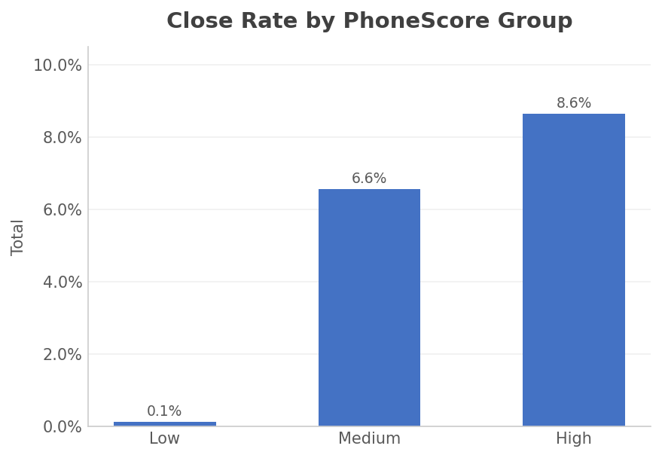

PhoneScore Group | Close Rate | Performance
High | 8.6% | ★ Strong
Medium | 6.6% | Moderate
Low | 0.1% | Very Weak

AddressScore vs. Close Rate

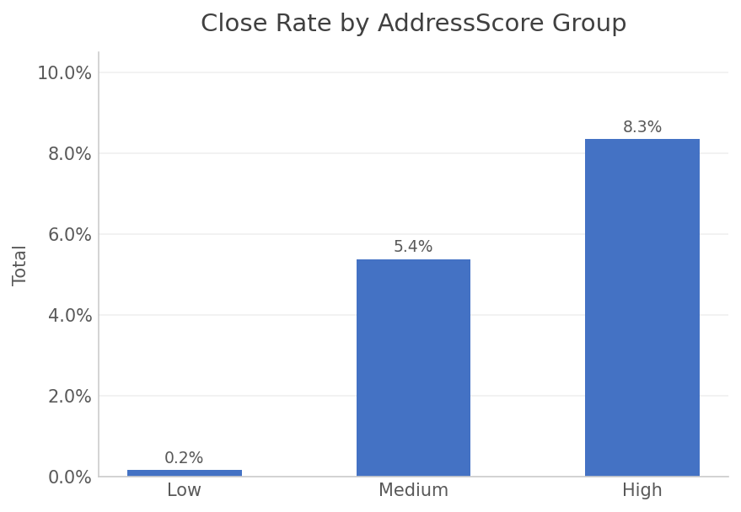

AddressScore Group | Close Rate | Performance
High | 8.3% | ★ Strong
Medium | 5.4% | Moderate
Low | 0.2% | Very Weak

Key Insight: Higher validation scores strongly correlate with close rates. Low-score leads produce negligible conversion. Pre-validation filtering is the single strongest optimisation opportunity identified in the dataset.

8. Recommendations
The following recommendations are prioritised by estimated impact on lead quality and CPL justification:

Recommendation 1: Implement Pre-Validation Lead Filtering
Leads with high PhoneScore and AddressScore demonstrated close rates up to 86× higher than low-score leads. Applying pre-validation filters to exclude low-score leads before delivery would materially lift overall lead quality and downstream ROI.

Recommendation 2: Reallocate Spend Toward Top-Performing Widgets
CreditSolutions (45% good lead rate) and BlueMeter (67%) creative variants outperformed on lead quality. Shifting budget away from underperforming variants toward these themes could improve quality without increasing CPL.

Recommendation 3: Reduce or Redesign 'Yellowarrow' Variants
Yellowarrow creatives (41% good lead rate) consistently underperformed. These variants should be redesigned, retargeted, or removed from the media mix to reduce waste.

Recommendation 4: Improve Operational Follow-Up for Unknown Leads
~71% of leads are unresolved. Resolving even a portion of these through improved follow-up workflows would significantly improve campaign visibility and optimisation accuracy.

Recommendation 5: Optimise Traffic by Placement & Geography
Publisher zone and state-level data reveal meaningful quality differences. Prioritising TopLeft placements and high-performing geographic segments can improve quality at equivalent CPL.

9. Conclusion
This analysis identified meaningful differences in lead quality across creatives, acquisition sources, geographic segments, and validation-quality indicators.

While weekly lead quality fluctuations were not statistically significant, several high-confidence operational and creative optimisation opportunities exist. The strongest lever is pre-validation score filtering, which has the potential to dramatically improve downstream close rates.

Implementing the recommendations above — particularly validation filtering and widget reallocation — could materially improve lead quality, reduce waste, and provide a robust basis for justifying a 20% CPL increase with the advertiser.

These findings demonstrate that the path to a higher CPL is not through more leads, but through smarter qualification, better creatives, and data-driven traffic allocation.

Appendix: Tools & Methodology

Tools Used
- Microsoft Excel – primary analysis environment
- Pivot Tables – segmentation and KPI calculation
- Chi-Square Testing – statistical significance validation
- Segmentation & KPI Analysis – trend and quality profiling
- Data Visualisation – trend and distribution charting

Analytical Approach
- Lead quality was mapped from raw CallStatus fields into Good / Bad / Unknown categories.
- Known leads (Good + Bad) were used as the denominator for quality rate calculations.
- Statistical testing was applied to determine whether observed trends were meaningful.
- Validation score correlation was measured using actual close rates by segment, not averages.

